Daniel DeCarlo

Box # 107

Cairn University School of Business

CIS122 Essentials of Networking

Project # 8

Project objective: The objective of this project is to create a virtual private network (VPN) to establish a secure communication network. With a secure and reliable VPN, data sent over the network from a public to private network will be protected from anyone trying to compromise or steal the data.

Equipment used:

|  |  |  |  |  |
| --- | --- | --- | --- | --- |
| Equipment Description | Vendor | Vendor Item # | Retail price | Actual price (if known) |
| Windows 10 OS | Microsoft | Version:1809  OS build: 17763.379 | Depends on version of windows purchased. |  |
| Cisco ASDM 7.8(2) VPN Certificate software | Cisco | cisco ASDM 7.8(2) | Free |  |
| Firewall Cisco ASA5505-BUN-K9 ASA 5505 | Cisco/Amazon  https://www.amazon.com/Cisco-ASA5505-BUN-K9-ASA-5505/dp/B000O0Z8GC/ref=sr_1_6?keywords=cisco+firewall&qid=1555351998&s=gateway&sr=8-6 | ASA5505-BUN-K9 | $200 (on sale)  X2 =  $400 | $410 |

Detailed list of software and operating platforms used, including version numbers and licensing requirements:

* Windows 10 Version:1809, OS build: 17763.379
* Cisco cisco ASDM 7.8(2)

Network diagram:

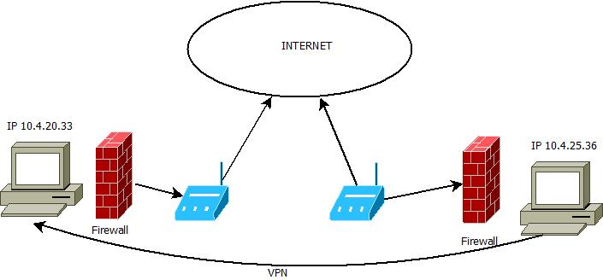

Configurations:

1. For setting up a VPN you are going to need a VPN subscription from any provider and in this case we are using cisco. Download the VPN or purchase the VPN depending on the version you choose.
2. When you choose the subscription download the ASMD software from Cisco from the following link. Make sure you log in to download the software.

<https://www.pcworld.com/article/210562/how-set-up-vpn-in-windows.html>

1. When the software is finished downloading open it and sign into your cisco account. Then fill out the prompts on the screen about your VPN information.
2. Fill out the information like “username”, “VPN provider”, “connection name”, “the server address”, and other prompts.

**For Server address use ASA 5505. **

1. Fill out username and password, most passwords on Cisco is “cisco”.
2. After all the prompts are answered the VPN should be complete and there should be a connection between the device and the network you are trying to communicate with.